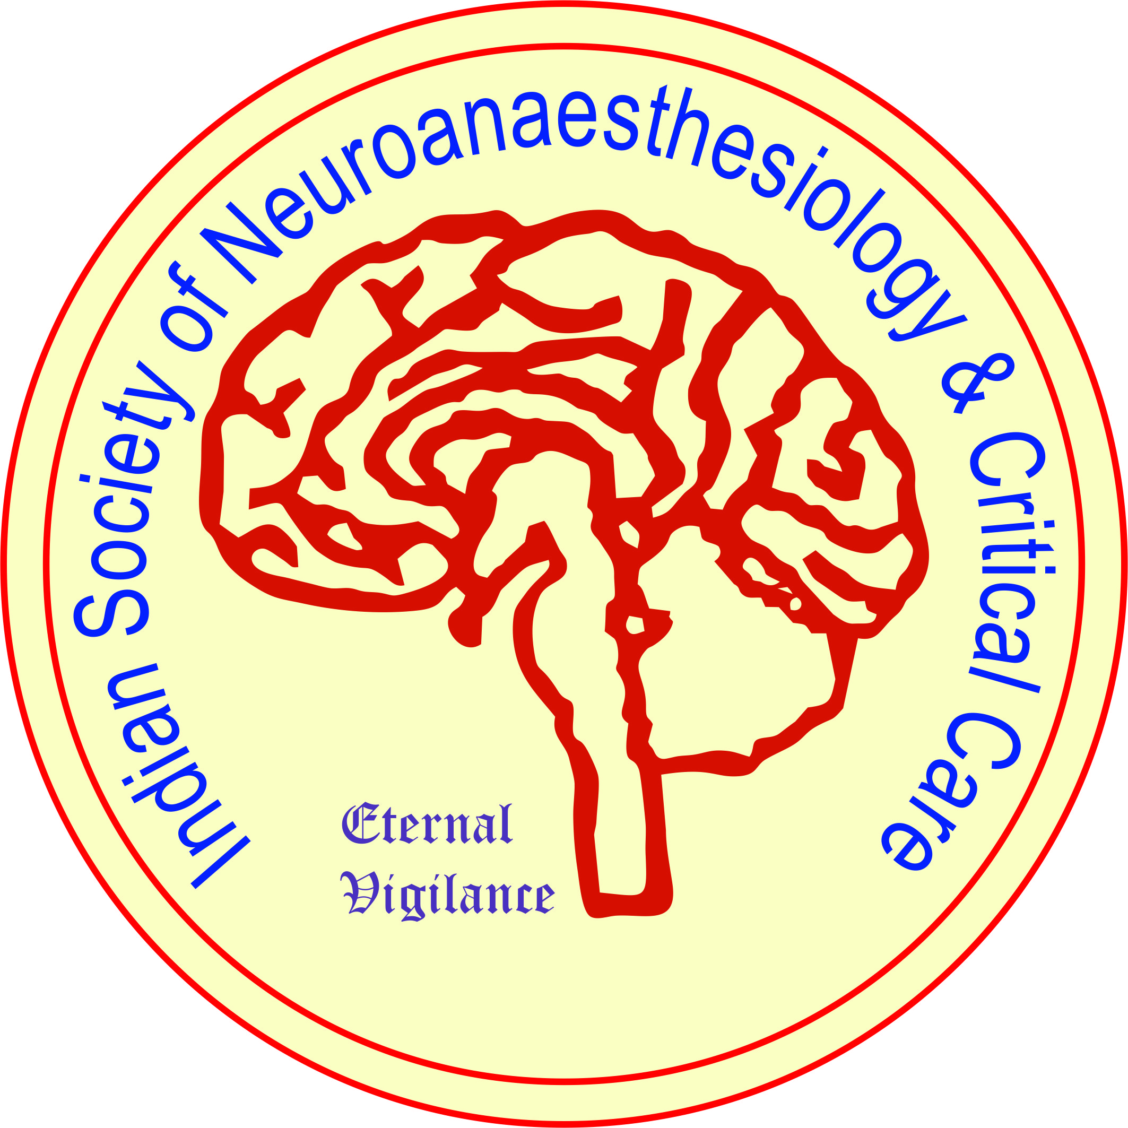
MEMBERSHIP FORM
ISNACC

MEMBERSHIP CATEGORY: LIFE MEMBER ASSOCIATE LIFE MEMBER

INTERNATIONAL LIFE MEMBER ALLIED MEMBER
PERSONNEL DETAILS:
Passport Photo

First Name:

nghSingh
Middle Name: Last Name:

Date of Birth: Day: Month: Year:

Qualification:

Designation:

Work Place:

yaninder Pal Singh
ADDRESS FOR CORRESPONDENCE:

City: State: PIN: Country:

Email ID: Mobile No:

PERMANENT ADDRESS:

City: State: PIN: Country:

Proposed by:
(Name) (Membership No.) (Signature)

Seconded by:
(Name) (Membership No.) (Signature)

Payment Details: NEFT/ IMPS/Cash/ DD/ Cheque No: Date:

Amount Rs. Drawn On (Name of the Bank):

Date: (Signature of the applicant)

For Office Use

Receipt Number: Date: Amount:

Membership (Confirmed / Rejected): Membership No:
ISNACC

Date:
Signature

Membership Fees

LIFE MEMBER: Neuroanaesthesiologists, Neuro-Intensivists  ASSOCIATE LIFE MEMBER: Neurosurgeons, Neurologists, Neuropathologists, Intensivists, Neuropathologists, Neuromicrobiologists, Neurobiochemists, Neuroscientists, Neuropsychologists etc.  INTERNATIONAL LIFE MEMBERS: Physicians of Foreign origin | Rs. 8000/- (Rupees Eight thousand only)  200 USD (For Foreign Nationals)
ALLIED MEMBER: Neuro-Nurses, Neuro-Physiotherapists, and Neuro-Technicians | Rs. 3000 (Rupees Three Thousand only)  75 USD (For Foreign Nationals)
Mode of Payment

- Cash/ DD/ At par Cheque to be drawn in favour of
‘Indian Society of Neuroanaesthesiology and Critical Care’ Payable at SBI, Ansari Nagar, New Delhi

- NETF/ IMPS/ Google Pay :
Bank: State Bank of India (SBI) Branch: Ansari Nagar, New Delhi
Name of the Account: Indian Society of Neuroanaesthesiology and Critical Care
Account No: 32266570538 IFSC: SBIN0001536 MICR: 110002005

(Note: Please mention the details of Payment in the Application form)

